Tim Chapin
support@cdc-tek.com

CDC Software Platform Connector for Mulesoft AnyConnect
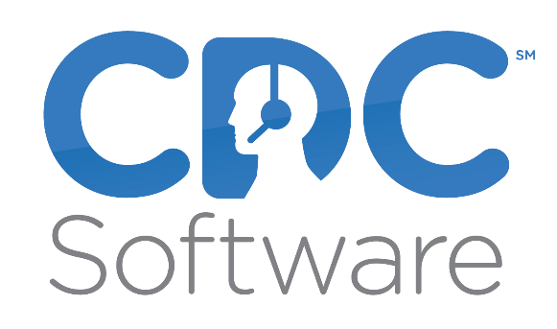
Contents
Introduction 2
Prerequisites 3
Compatibility 3
Installation 4
Configure Global Element 4
Using The Connector 6
Adding the Connector to a Mule Flow as Stream Source 6
Adding the Connector to a Mule Flow as a Process 7
Use Cases 8
Create a Mule application that generates an email at the end of a call 9

Introduction
The Anypoint CDC Software Connector provides connectivity to the CDC Software API, enabling you to interface with CDC Software to retrieve telephony events and perform operations on more than a dozen telephony systems.

Prerequisites
To use the CDC Software connector, you must have the following:
- CDC Software Platform installed and configured for the telephony system(s) to be used.

Compatibility
CDC Software connector is compatible with:
Application/Service | Version
Mule Runtime | 3.5.0 or later
CDC Software Platform | 1.0 or above
Telephony Systems Supported:
- Asterisk and Asterisk based systems.
- Broadsoft and Broadsoft based systems.
- Alcatel-Lucent OMNI Systems with CSTA
- Avaya Aura with Application Enablement Services 5.0 or above
- Avaya Aura with Avaya Communications Control Toolkit
- Avaya IP Office 8.x and above with CTI Link Pro
- Cisco CUCM 7.5 and above
- Cisco UCCE 7.5 and above
- Cisco UCCX 7.5 and above
- InContact
- Mitel with Open Integration Gateway 3.0 and above
- ShoreTel
- Switchvox
- Vonage Business
- Other systems that support: TAPI, CSTA, or TSAPI

Installation
The following sections describe how to install and configure this connector.

Configure Global Element
To use the CDC Software connector in your Mule application, you must configure a global CDC Software element that can be used by all the CDC Software connectors in the application (read more about Global Elements.)
- Studio Visual Editor
- XML Editor
- Click the Global Elements tab at the base of the canvas, then click Create.
- In the Choose Global Type window, expand Connector Configuration, and click CDC Software: Configuration.
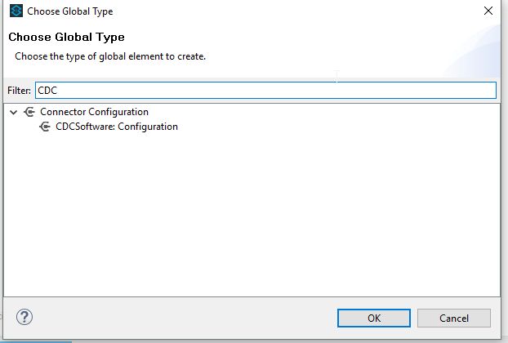

- Click Ok
- Enter the global element properties:
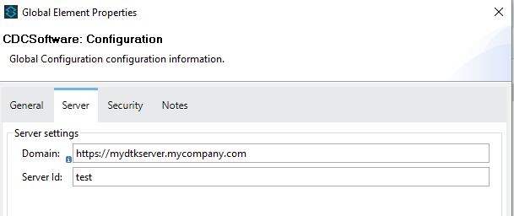

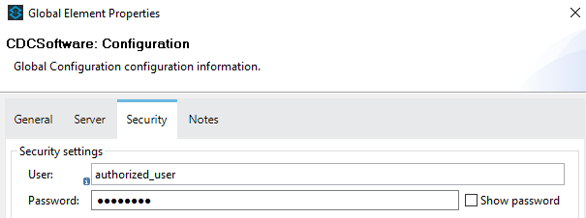

Parameter | Description
Name | Enter a name for the configuration to reference it.
Domain | The URL of your DTK installation
Server Id | The instance name of your installation
User | The authorized user
Password | The authorized user password

You can either enter your credentials into the global configuration properties, or reference a configuration file that contains these values. For simpler maintenance and better re-usability of your project, Mule recommends that you use a configuration file. Keeping these values in a separate file is useful if you need to deploy to different environments, such as production, development, and QA, where your access credentials differ. See Deploying to Multiple Environments for instructions on how to manage this.
- Click OK to save the global connector configurations.

Using The Connector
CDC Software connector as a stream connector currently supports the following list of operations:
- Get Events
CDC Software connector as an operation connector currently supports the following list of operations:
- Make Call
- Answer Call
- Release Call

Adding the Connector to a Mule Flow as Stream Source
- Create a new Mule project in Anypoint Studio.
- Drag the CDC Software connector onto the canvas, then select it to open the properties editor.
- Configure the connector by using previously define configuration and selecting the “Get events” operation.
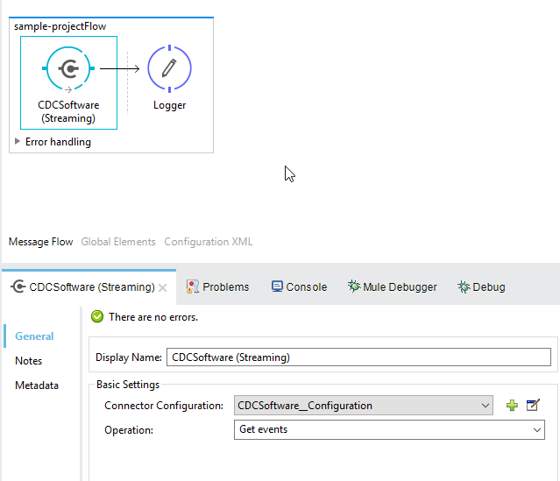

Adding the Connector to a Mule Flow as a Process

- Create a new Mule project in Anypoint Studio.
- Drag the CDC Software connector onto the process section of the flow.
- Configure the connector by using previously define configuration and select the processor operation.
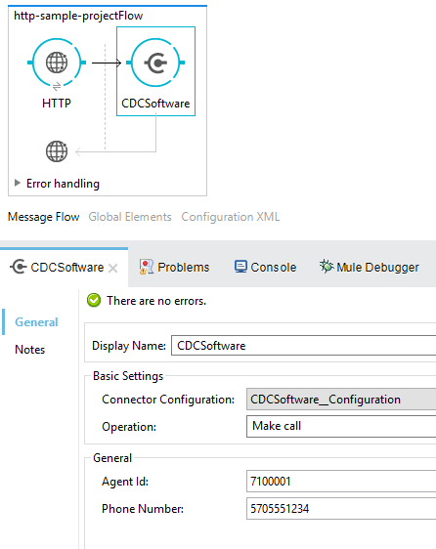

Use Cases

The primary purpose of the CDC Software Platform Connector is to expose the primary call events of the supported telephony systems directly to Mulesoft to support the triggering of actions within other Mulesoft connectors. For example, the answering of a call could be mapped to a action (create, modify, search etc.) in another Mulesoft connector. Examples might be:
- Screen-popping a CRM.
- Updating or opening a webpage or web service
- Sending an email
- Writing or reading a record to/from a DB

Create a Mule application that generates an email at the end of a call
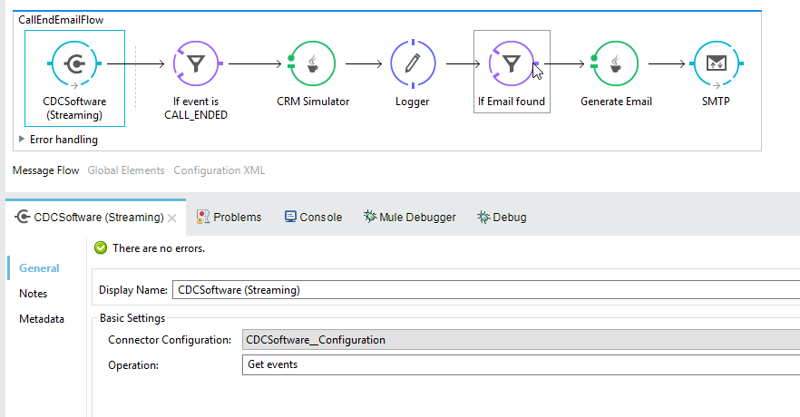
- Create a new Mule project in Anypoint Studio.
- Drag a CDCSoftware into the canvas, then select it to open the properties editor console.
- Configure the CDCSoftware connector with domain, server id , user and password.
- Drag an Expression Filter, and double-click the connector to open its Properties Editor.
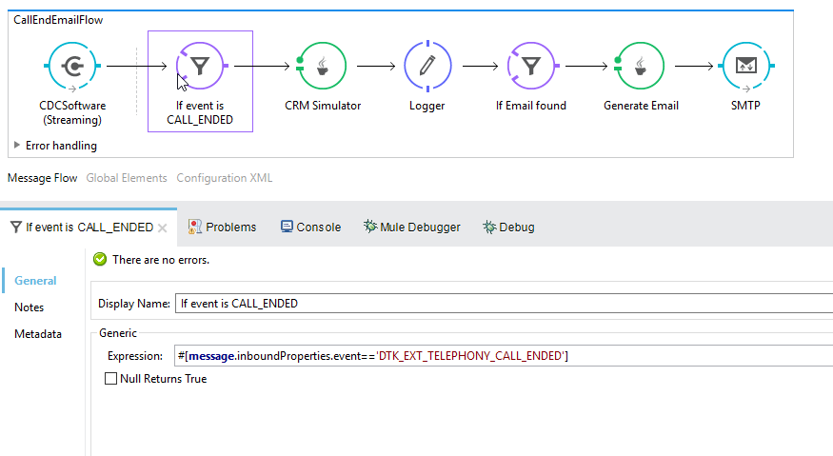
- Edit the expression to filter by DTK event CALL END #[message.inboundProperties.event=='DTK_EXT_TELEPHONY_CALL_ENDED']
- Drag a Java Transformer to create your custom logic to retrieve customer email by phone as example below:
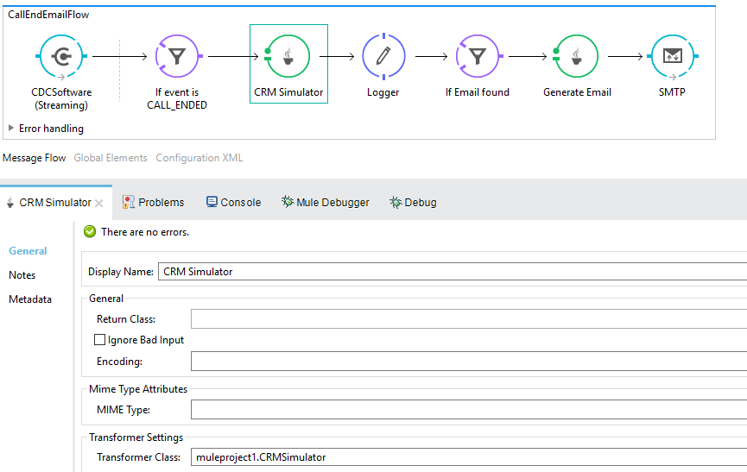

- Example Java code
- package muleproject1;

- import java.util.Map;
- import java.util.HashMap;
- import org.mule.api.MuleMessage;
- import org.mule.api.transformer.TransformerException;
- import org.mule.api.transport.PropertyScope;
- import org.mule.transformer.AbstractMessageTransformer;
- public class CRMSimulator extends AbstractMessageTransformer{
- public Object transformMessage(MuleMessage message,
- String outputEncoding) throws TransformerException {

- String phone =
- message.getProperty("phone",PropertyScope.INBOUND).toString();
- Map<String,Object> map = new HashMap<String,Object>();

- switch (phone) {
- case "3055551234":
- map.put("name", "joe");
- map.put("email", "joe@mycompany.com");
- break;

- default:
- map.put("name", "notfound");
- map.put("email", "notfound");

- break;
- }

- message.addProperties(map, PropertyScope.OUTBOUND);
- return message;
- }
- }

- Drag a Logger component to log the results of your Java code
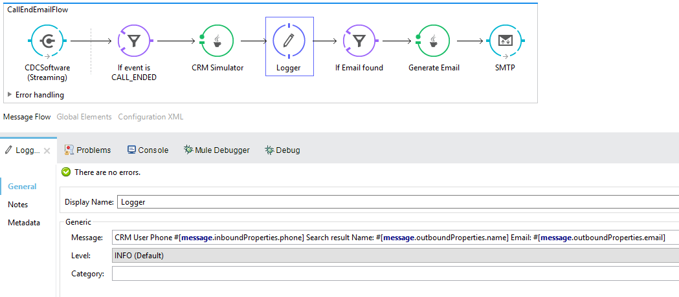
- Drag an expression filter to filter message that do not contain ‘notfound’ in the email property
#[message.outboundProperties.email!='notfound']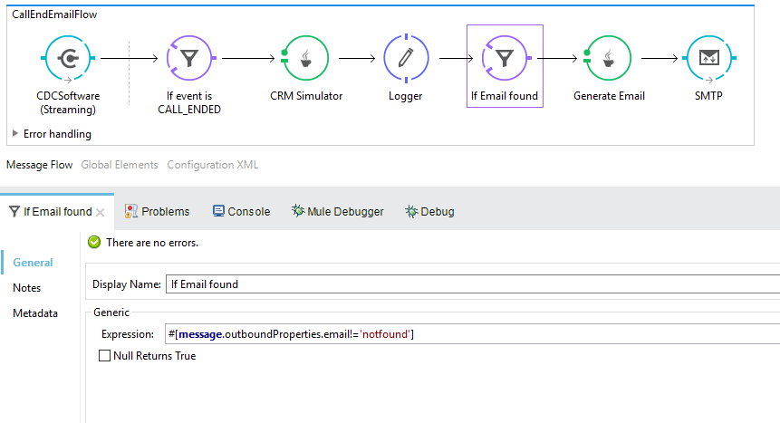

- Drag another Java Transformer to customize the email body
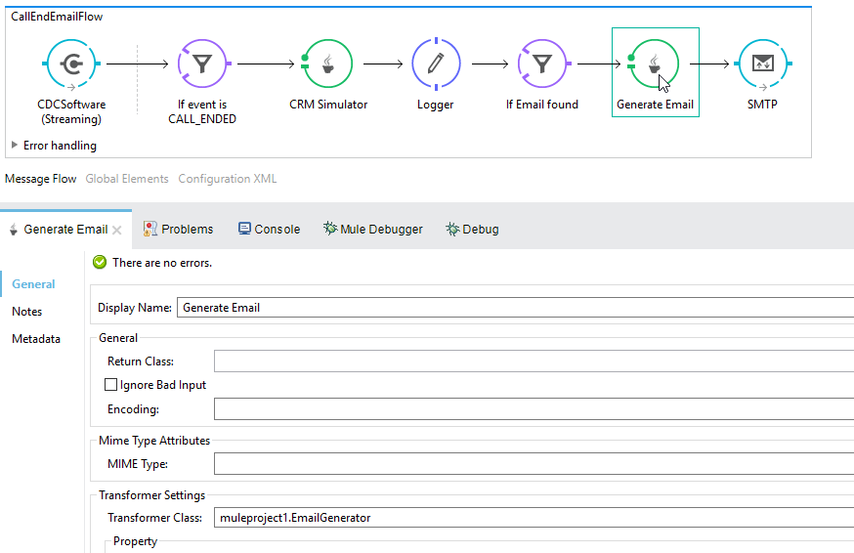
- Example Java code
- package muleproject1;
- import org.mule.api.MuleMessage;
- import org.mule.api.transformer.TransformerException;
- import org.mule.api.transport.PropertyScope;
- import org.mule.transformer.AbstractMessageTransformer;
- public class EmailGenerator extends AbstractMessageTransformer{
- public Object transformMessage(MuleMessage message, String
- outputEncoding) throws TransformerException {
- String phone =message.getProperty("phone",PropertyScope.INBOUND).toString();

- String name =message.getProperty("name",PropertyScope.OUTBOUND).toString();

- StringBuilder sb = new StringBuilder();
- sb.append("Dear: ");
- sb.append(name);
- sb.append("\r\n");
- sb.append("We would like to thank you for your call from ");
- sb.append(phone);

- return sb.toString();

- }
- }
- Drag an SMTP endpoint to send the email to the customer that was found previously:
